Brian Engel

SQL Injection Activity

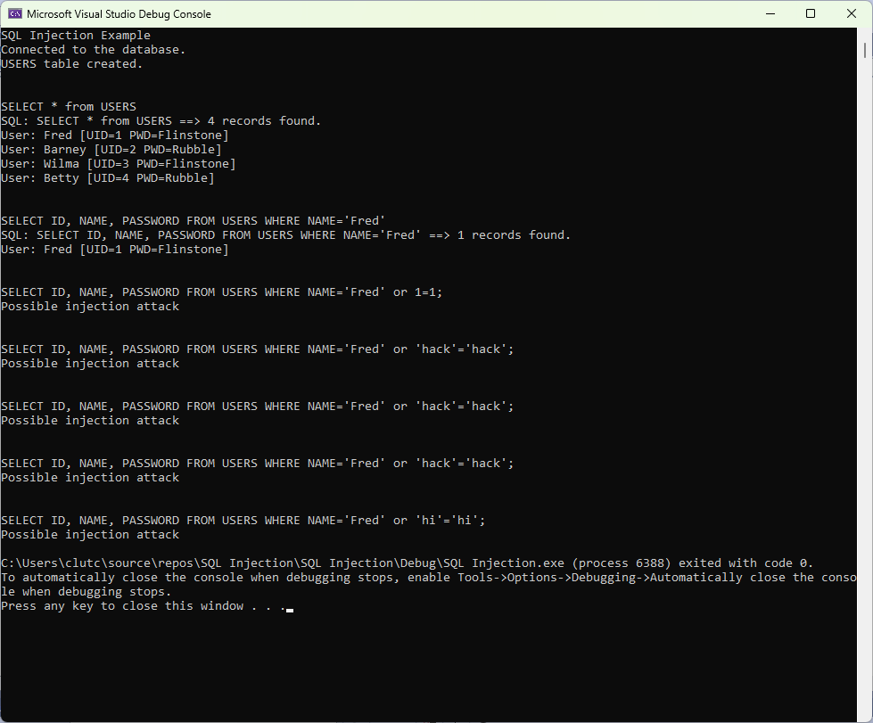

I took the approach that if the word “or” was in the query it is probably an injection attack. I created a vector of strings of words that can be used for injection. In our case it was just "or”, but I added the space in front and back to distinguish it from "or" in a word such as "Victor". Can also easily add other symbols or words.

Next, I copied the SQL string and made it lowercase so it can handle capital or lowercase in the string. This is just used for the comparison and not in the actual query.

Then I searched the lowercase string for the words / symbols in the vector of suspicious words. For us it is just “ or “. If it is found there is an output that says “Possible injection attack” and returns false since the query never runs.